

Lab 3
COMP6042_26213 Operating Systems in Practice
Student ID: R00201303
Date: 05.04.2022
Group: COMP1D-Y
Question1:
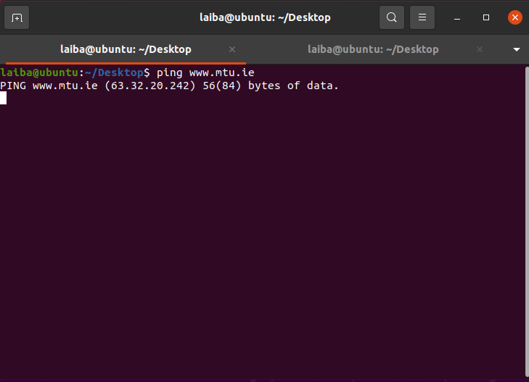
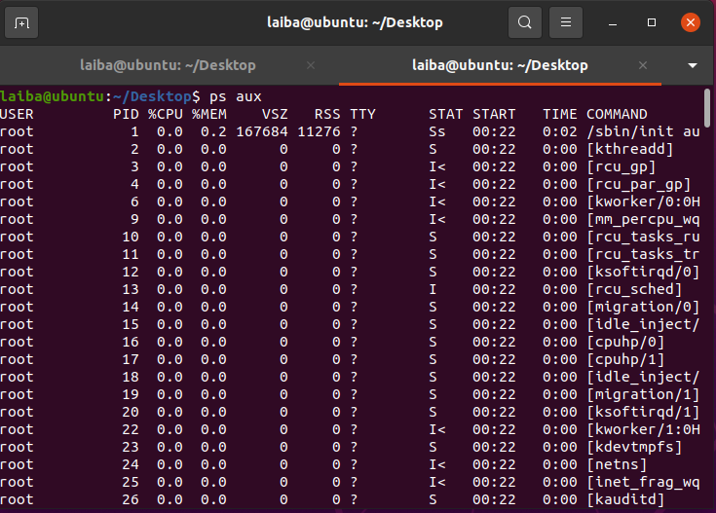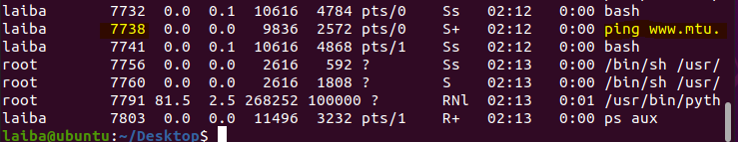
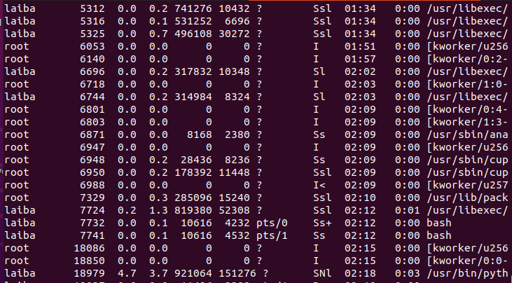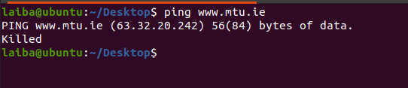
Question2:
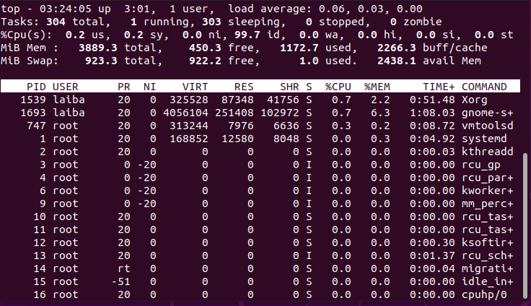
Highlight Running Process in Top: 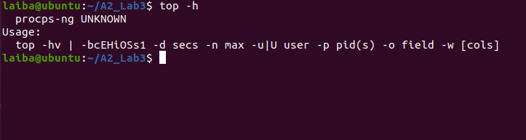
Q. Write a report describing the top command.
Ans: To view the Linux processes, use the top command. It gives a dynamic, real-time perspective of the system in action. This command often displays the system's summary information as well as a list of processes or threads that the Linux Kernel is presently managing. When you run this command, it will launch an interactive command mode with statistics on processes and resource utilization in the upper half of the screen. A list of presently operating processes may be seen in the lower portion. The command mode can be exited by pressing q.
Display Specific User Process:
top -u paras
Highlight Running Process in Top:
top -h
Batch Mode : Send output from top to file or any other programs:
top -b
Secure Mode : Use top in Secure mode:
top -s
Command Line : The below command starts top with last closed state:
Top -c
Delay time : It tells delay time between screen updates:
Top -d seconds.tenths

Question3:
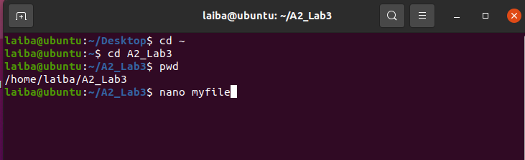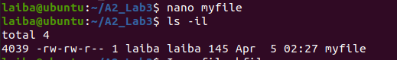
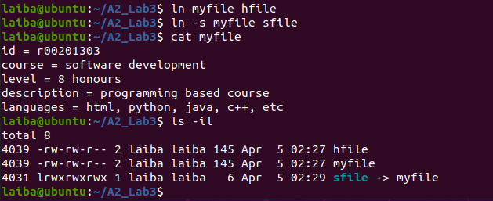
Q. What you notice about the inodes displayed by the ls command.
Ans: Except for the data and name, an inode number maintains all the information about a conventional file, directory, or other file system object. Use the ls or stat commands to locate an inode. 4039 is the inode number, 1 indicates that this file is linked to data. and the -i option displays the index number (inode).
Q. What is a hard link? What is a hard link used for? Why are hard links used in Linux?
Use the above files to illustrate your understanding, and clearly describe each aspect
of hard links in relation to the original file.
Ans: A hard link is a reference to actual data on a storage device, often known as a pointer.
All named files on most file systems are hard links. The file's name is nothing more than a label that directs the operating system to the real contents. As a result, the same data can be associated with many names; nonetheless, any modifications made will alter the actual data, regardless of how the file is named later. Only data on the same file system can be referenced via hard links. Hard connections between devices are not possible. The purpose of a hard link in Linux is that it allows us to take one file and have it be in multiple places in the filesystem at once.
Q. What is a soft link? What is a soft link used for? Why are soft links used in Linux?
Use the above files to illustrate your understanding, and clearly describe each aspect
of soft links in relation to the original file.
Ans: A symbolic link (sometimes called a soft link) is a specific sort of file that serves as a pointer to another file. A symbolic link contains a symbolic path that an operating system uses to determine if a hard link (or another symbolic link) exists. Soft links are helpful for establishing connections between partitions and media (such as USB devices). In run-level files, soft linkages can be identified. We need a soft link in Linux as it contains the path for the original file and not the contents
Question4:
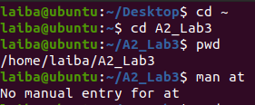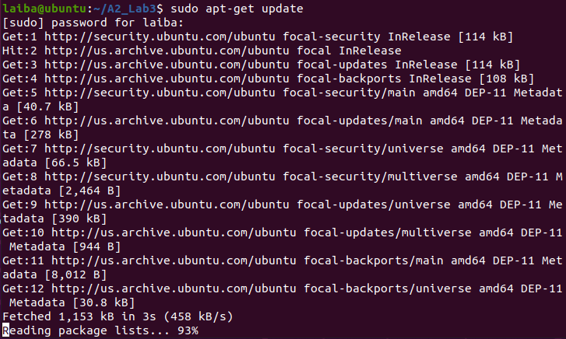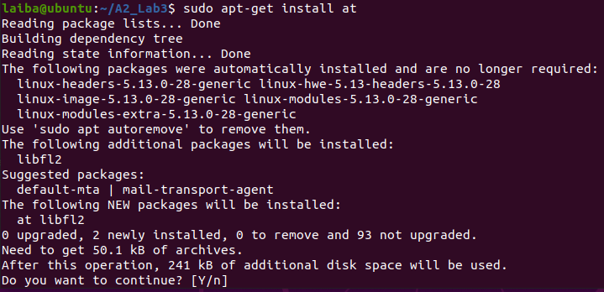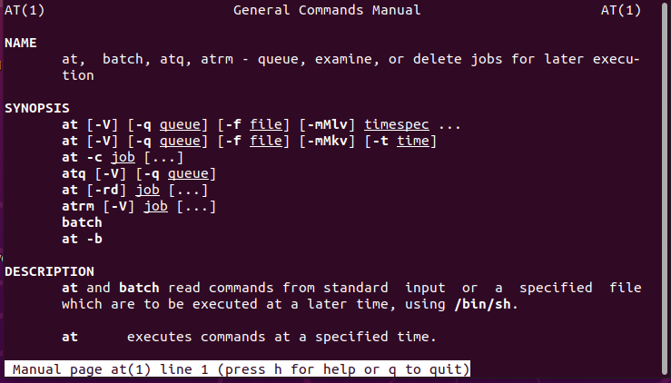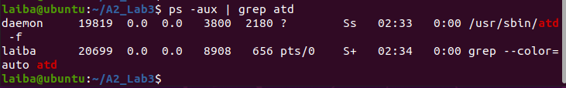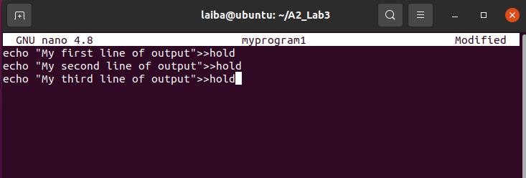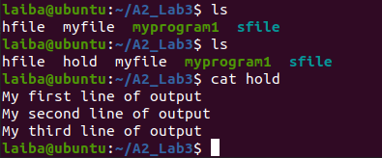
Q. Type ls -Does the hold file exist?
Ans: no
Q. After 2 minutes, type ls -Does the hold file exist?
Ans: yes
Q. Explain, in detail, what has happened and why.
Ans: File hold is a mechanism to restrict access to a file among multiple processes. It allows only one process to access the file in a specific time, thus avoiding the interceding update problem.
Q. What is a daemon?
Ans: A daemon is a background service process that monitors the system or offers functionality to other processes. In Linux, they are background-running utility applications that monitor and maintain specific subsystems to ensure that the operating system functions smoothly. The letter "d" appears in almost every daemon's name. For instance, httpd is the daemon that manages the Apache server, while sshd is the daemon that manages SSH remote access connections.

